

**Penrhos College**

**Semester 2 Examination, 2011**

**Question/Answer Booklet**

MATHEMATICS SPECIALIST:

3C/3DMAS

**Section Two:**

**Calculator-assumed**

**Student Name:____SOLUTIONS_____**

**Time allowed for this section**

Reading time before commencing work: 10 minutes

Working time for section: 100 minutes

**Material required/recommended for this section**

***To be provided by the supervisor***

Question/answer booklet for Section Two. Candidates may use the removable formula sheet from Section One

***To be provided by the candidate***

Standard items: pens, pencils, pencil sharpener, highlighter, eraser, ruler

Special items: drawing instruments, templates, notes on up to two unfolded sheets of A4 paper, and up to three calculators, CAS, graphic or scientific, which satisfy the conditions set by the Curriculum Council for this course.

**Important note to candidates**

No other items may be taken into the examination room. It is **your** responsibility to ensure that you do not have any unauthorised notes or other items of a non-personal nature in the examination room. If you have any unauthorised material with you, hand it to the supervisor **before** reading any further.

***Instructions to candidates***

1. **All** questions should be attempted.

2. Write your answers in the spaces provided in this Question/Answer Booklet. Spare answer pages may be found at the end of this booklet. If you need to use them, indicate in the original answer space where the answer is continued (i.e. give the page number).

3. **Show all your working clearly.** Your working should be in sufficient detail to allow your answers to be checked readily and for marks to be awarded for reasoning. Incorrect answers given without supporting reasoning cannot be allocated any marks. For any question or part question worth more than two marks, valid working or justification is required. If you repeat an answer to any question, ensure that you cancel the answer you do not wish to have marked.

4. It is recommended that you **do not use pencil** except in diagrams.

**Section Two: Calculator-assumed (80 Marks)**

This section has **twelve (12)** questions. Answer **all** questions. Write your answers in the space provided.

Suggested working time for this section is 100 minutes.

**Question 9 (4 marks)**

Use proof by exhaustion to prove that 127 is a prime number.

|  |
| --- |
| **Solution** |
| If 127 is a prime number it is not divisible by another prime number.  127 ÷ 2 = 63.5  127 ÷ 3 = 42.3  127 ÷ 5 = 25.4  127 ÷ 7 = 18.14  127 ÷ 11 =11.55  As  there can be no other prime factors of 127.  ∴ 127 has no other factors other than 1 and itself  i.e. 127 is prime |
| **Specific behaviours** |
| ✓ States that a prime number is not divisible by another prime number  ✓ Follows process of exhaustion for dividing 127 by all possible prime numbers  ✓ States why the process is exhausted  ✓ establishes correct conclusion |

Question 10 (9 marks)

The triangle *ABC* with vertices *A*(0, 0), *B*(3, 1) and *C*(-1, 2) is transformed by the matrix  on to the triangle *A*'*B*'*C*'.

(a) Determine the coordinates of *A*' and *C*'.

[2]

|  |
| --- |
| **Solution** |
| *A*'(0, 0).  *C*’(4, 1) |
| **Specific behaviours** |
| ✓ correctly determines *A*’  ✓ correctly determines C’ |

(b) The area of triangle *A*'*B*'*C*' is 7 square units. What is the area of triangle *ABC*?

[2]

|  |
| --- |
| **Solution** |
| Area of ABC = 7 ÷ ⏐2⏐  = 3.5 units2 |
| **Specific behaviours** |
| ✓ correctly calculates the value of the determinant  ✓ correct area of triangle |

(c) Matrix ***M*** represents a combination of transformation ***X*** followed by transformation ***Y***. If the matrix for transformation , determine the matrix for transformation ***Y*** and describe the geometric transformation ***Y*** represents.

[3]

|  |
| --- |
| **Solution** |
| ***Y*** represents a dilation factor 2 parallel to x-axis |
| **Specific behaviours** |
| ✓ correctly acknowledges ***YX*** = ***M***  ✓ correctly calculates matrix ***Y***  ✓ correctly describes matrix ***Y*** geometrically |

(d) The triangle *A*'*B*'*C*' then undergoes a shear of factor  parallel to the *y*-axis such that the image of the coordinate *C*' is (4, -3). Determine the value of.

[2]

|  |
| --- |
| **Solution** |
|  |
| **Specific behaviours** |
| ✓ obtains an expression to solve involving *k*  ✓ correctly calculates *k* |

**Question 11 (6 marks)**

The complex number  satisfies the inequality .

(a) Show that 

[3]

|  |
| --- |
| **Solution** |
|  |
| **Specific behaviours** |
| ✓ substitutes *x* – *yi* and *x* + *yi* into the inequality  ✓ expands and simplifies expression  ✓ deduces the required result |

(b) Hence sketch the set of all complex numbers *z* that satisfy the inequality  on the axes below.

[3]

|  |
| --- |
| **Solution** |
|  |
| **Specific behaviours** |
| ✓ correct plotting of *xy* =4  ✓ correct plotting of *xy* = -4  ✓ solid line and correct shading |

**Question 12 (8 marks)**

(a) According to research carried out by a company the proportion of households switching between oil, gas and electric heat in the United States after 1 year is shown in the table below.

|  |  |  |  |  |
| --- | --- | --- | --- | --- |
|  |  | To | | |
|  |  | Oil | Gas | Electric |
| From | Oil | 70% | 30% | 0 |
| Gas | 10% | 80% | 10% |
| Electric | 20% | 0 | 80% |

If the pattern of switching types of heating continues

(i) determine the proportion of current households using gas who will be using gas in 5 years time.

[2]

|  |
| --- |
| **Solution** |
| 50.3% |
| **Specific behaviours** |
| ✓Sets up transition matrix from table and raises to the power of 5  ✓ correct proportion of households |

(ii) determine in the long term what proportion, to 1 decimal place, of

households will be using each of the three forms of heating?

[2]

|  |
| --- |
| **Solution** |
| Oil 30.8%, gas 46.2% and electric 23.1% |
| **Specific behaviours** |
| ✓determines steady state matrix  ✓ correct proportions for each method of heating |

(b) A farmer is breeding marron in one of his dams. He has collected the following data on

their breeding and survival rates in 2003.

|  |  |  |  |  |
| --- | --- | --- | --- | --- |
| Age (years) | 1 | 2 | 3 | 4 |
| Population | 750 | 1200 | 900 | 600 |
| Birth Rate | 0 | 0.7 | 1.4 | 0.5 |
| Survival Rate | 0.7 | 0.6 | 0.5 | 0 |

1. Construct a Leslie matrix, ***L***, to represent this population.

[1]

|  |
| --- |
| **Solution** |
|  |
| **Specific behaviours** |
| ✓correctly sets up matrix from information in the table |

1. What is the total population in 2009?

[1]

|  |
| --- |
| **Solution** |
| The total population in 2009 is approximately 5123 marron. |
| **Specific behaviours** |
| ✓correct total population |

(iii) Over a period of time the population growth reaches a steady state of 6.5%. If in the long term the farmer wishes to maintain a stable population level in the dam what culling rate of each age group will the farmer need to set?

[2]

|  |
| --- |
| **Solution** |
| Let *k* be the proportion surviving after the cull    ∴ The culling rate will need to be 6.1% |
| **Specific behaviours** |
| ✓ correctly determines *k*  ✓ correctly determines the culling rate |

**Question 13 (6 marks)**

The velocity of a particle that travels in a straight line is given by , where *v* is in m/s and *t* is in seconds.

(a) Determine the times when the particle is at rest.

[2]

|  |
| --- |
| **Solution** |
|  |
| **Specific behaviours** |
| ✓ recognises that *t* = 0 when the velocity is at rest  ✓ correctly determines the two times the particle is at rest for |

(b) If the particle was initially at the origin determine an expression for its displacement.

[2]

|  |
| --- |
| **Solution** |
|  |
| **Specific behaviours** |
| ✓ integrates velocity to determine displacement  ✓ correctly determines the value of the constant and hence states the expression |

(c) Determine the distance the particle travelled in the third second.

[2]

|  |
| --- |
| **Solution** |
|  |
| **Specific behaviours** |
| ✓ integrates the absolute value of the velocity over the appropriate lower and upper limits  ✓ correctly determines the distance travelled in the third second |

**Question 14 (5 marks)**

The diagram below shows parallelogram *ABCD* where  and .

Point *X* divides *DB* internally in the ratio 2:1.

Point *M* is the midpoint of *AB*.

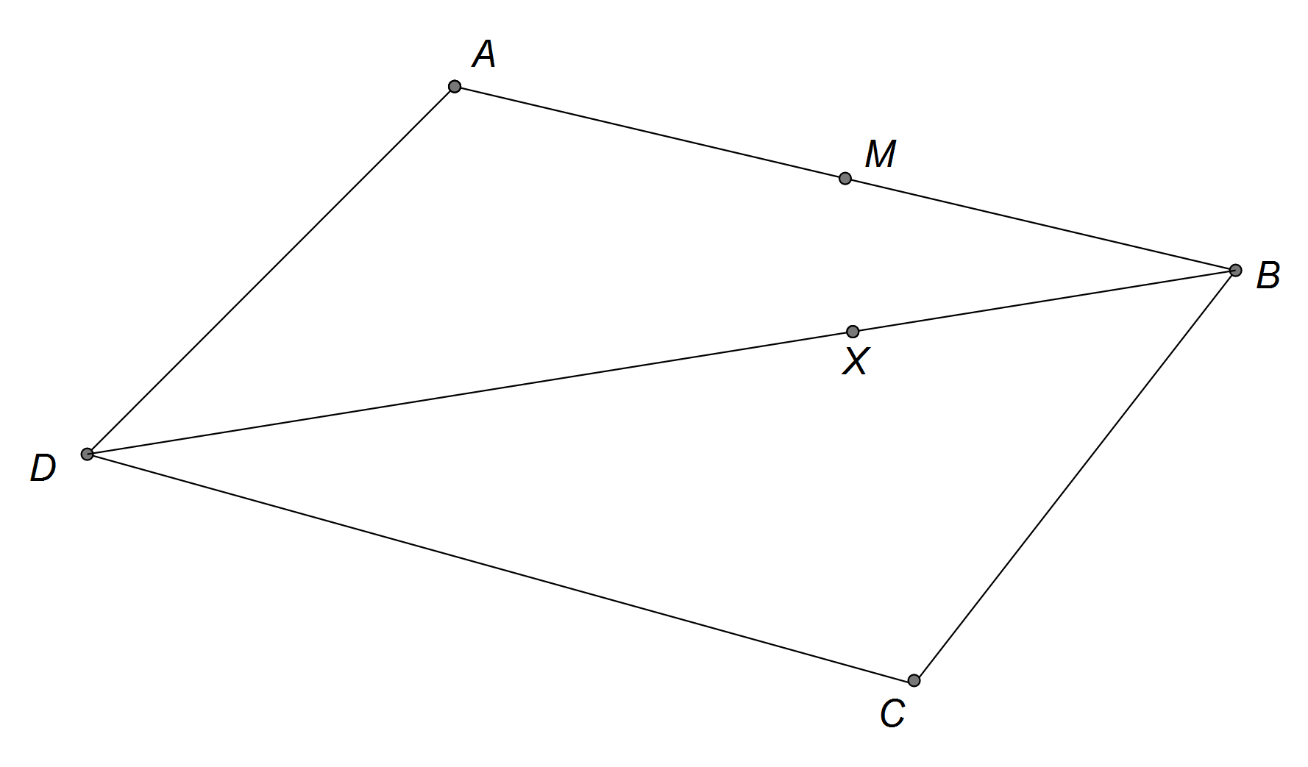

(a) Show that 

[1]

|  |
| --- |
| **Solution** |
|  |
| **Specific behaviours** |
| ✓ correctly shows |

(b) Find  in terms of ***a*** and ***b***.

[1]

|  |
| --- |
| **Solution** |
|  |
| **Specific behaviours** |
| ✓ determines correctly |

(c) Prove that points *M*, *X* and *C* are collinear.

[3]

|  |
| --- |
| **Solution** |
|  |
| **Specific behaviours** |
| ✓ determines an expression for  in terms of  and  ✓ shows is a scalar of  ✓ deduces the required result |

**Question 15 (5 marks)**

A certain type of electronic circuit will remain in a stable state if the values of two variable resistors, *x* and *y*, satisfy the equation .

In a particular circuit, the value of *y* is increasing at a rate of 15 units per second. At what rate must *x* be changing when *y* = 1000 for the circuit to remain stable?

|  |
| --- |
| **Solution** |
| OR    *x* is decreasing at a rate of 0.9375 units/sec |
| **Specific behaviours** |
| ✓ correctly determines expression for  ✓ correctly differentiates with respect to t  ✓ correctly determines expression for  ✓ correctly determines *x* when *y* = 1000  ✓ correctly calculates  ✓statement correctly interpreting the  rate is decreasing  ✓ correctly determines *x* when *y* = 1000  ✓ uses chain rule with  OR  ✓ correctly calculates  ✓statement correctly interpreting the  rate is decreasing |

**Question 16 (6 marks)**

A line and a plane are given by  and .

(a) Given that the point (2, *c*, -2) lies on the plane determine *c*.

[2]

|  |
| --- |
| **Solution** |
|  |
| **Specific behaviours** |
| ✓ substitutes point into equation of plane  ✓ correct value of *c* |

(b) Find the position vector of the intersection between the line and the plane.

[2]

|  |
| --- |
| **Solution** |
| Intersect when |
| **Specific behaviours** |
| ✓ correctly determines value of λ  ✓ correct point of intersection |

(c) Find the acute angle between the line and the plane.

[2]

|  |
| --- |
| **Solution** |
| Find angle between line and normal to plane: |
| **Specific behaviours** |
| ✓ correctly determines θ  ✓ correctly determines the acute angle between the line and plane |

**Question 17 (6 marks)**

The graph of  is shown below

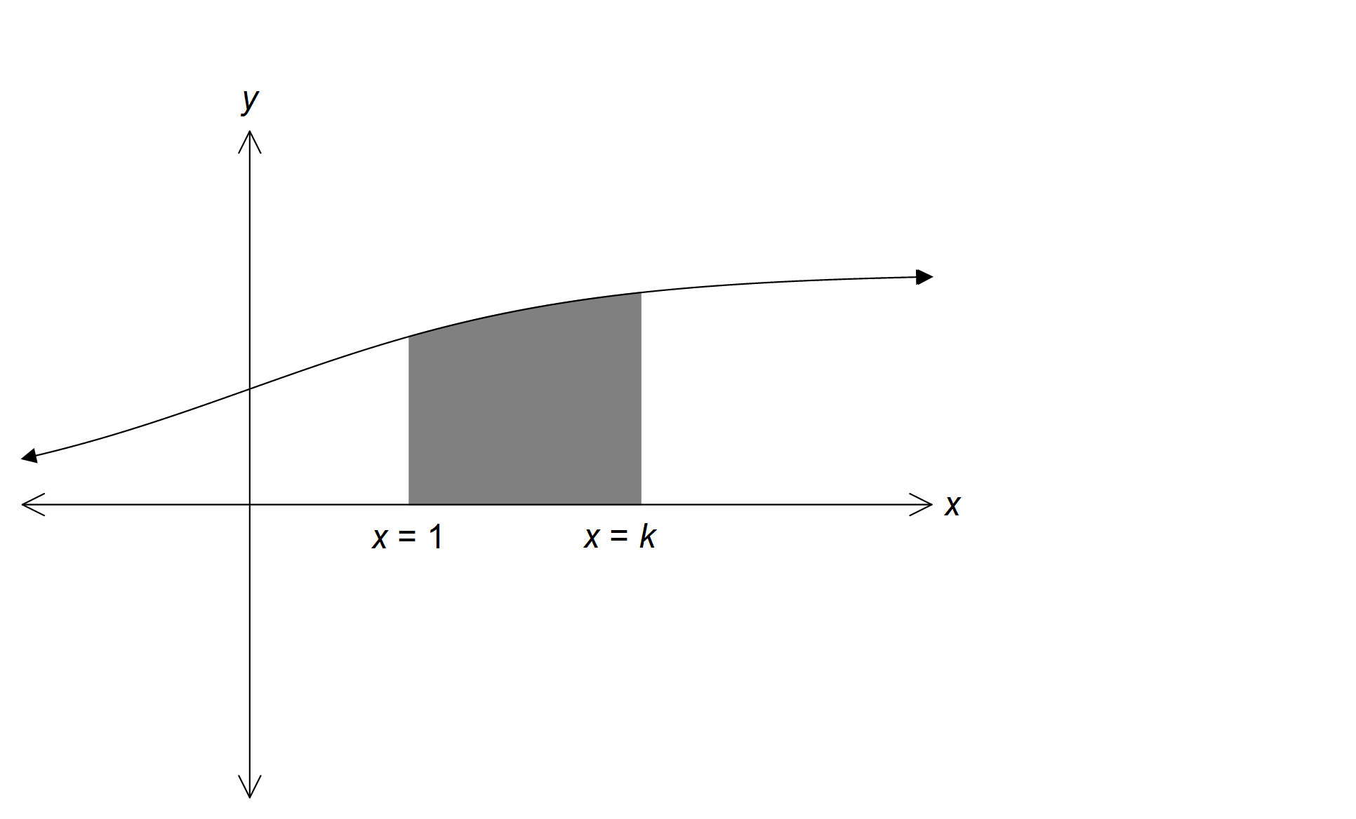

(a) Show that the area enclosed between the curve *f*(*x*) and the *x*-axis between *x* = 1

and *x* = *k*, is .

[3]

|  |
| --- |
| **Solution** |
|  |
| **Specific behaviours** |
| ✓recognises and integrates correctly  ✓substitutes upper/lower limits  ✓uses log laws to simplify expression and deduce required result |

(b) The graphs of *f*(*x*) and  are shown below. Determine the area bound by the two curves and the line *x* = 2.

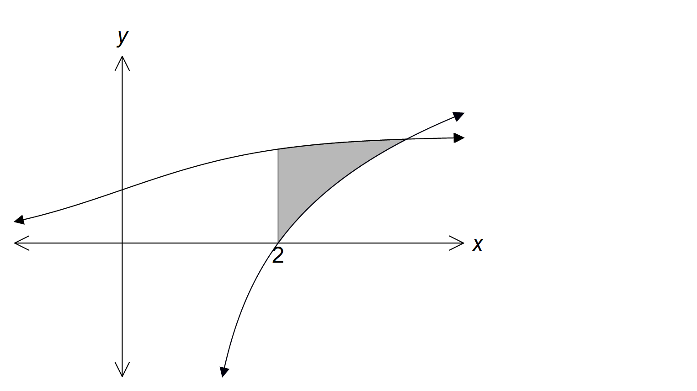

[3]

|  |
| --- |
| **Solution** |
| Value of *x* at point of intersection *x* ≈ 3.650 |
| **Specific behaviours** |
| ✓determines *x* value at point of intersection of functions  ✓determines an expression for the area between the curves  ✓ correctly determines the area of the required region |

**Question 18 (10 marks)**

An object, *P*, has an initial position of  metres and is moving with a constant velocity of  metres per second.

(a) A second object, *Q*, is moving with constant velocity of  metres per second and collides with object *P* after six seconds.

Determine the initial distance apart of object *P* and object *Q*.

[4]

|  |
| --- |
| **Solution** |
| *P* and *Q* collide at    Hence initial position of Q is at    Distance between *P* and *Q* is |
| **Specific behaviours** |
| ✓ determines point of collision  ✓ determines **r**Q  ✓ determines **QrP**  ✓ determine correct distance between  *P* and *Q* |

(b) A third object, *R*, is initially located at  metres and is also moving with a constant velocity  metres per second. Determine the value of *x* such that after 5 seconds the distance between objects *P* and *R* is minimised. State the minimum distance at this time.

[6]

|  |
| --- |
| **Solution** |
| Hence for the distance to be minimised after 5 seconds *x* = 5.6.  The minimum distance is 19.4 m |
| **Specific behaviours** |
| ✓ determines **r**P when t = 5  ✓ determines **r**R when t = 5  ✓ determines P**r**R when t = 5  ✓ Recognise need to find minimum of ⏐ P**r**R⏐  ✓ correct value of *x*  ✓ correct minimum distance |

**Question 19 (5 marks)**

The solution to the differential equation  passes through the point where *x* = 0 and *y* = 2. Determine *y* when *x* = 1.

|  |
| --- |
| **Solution** |
|  |
| **Specific behaviours** |
| ✓ separates variables  ✓ correctly determines antiderivatives  ✓ applies log definition  ✓ substitutes (0, 2) to calculate constant  ✓ deduce required result |

**Question 20 (10 marks)**

(a) One of the solutions to the equation  is shown on the graph below.

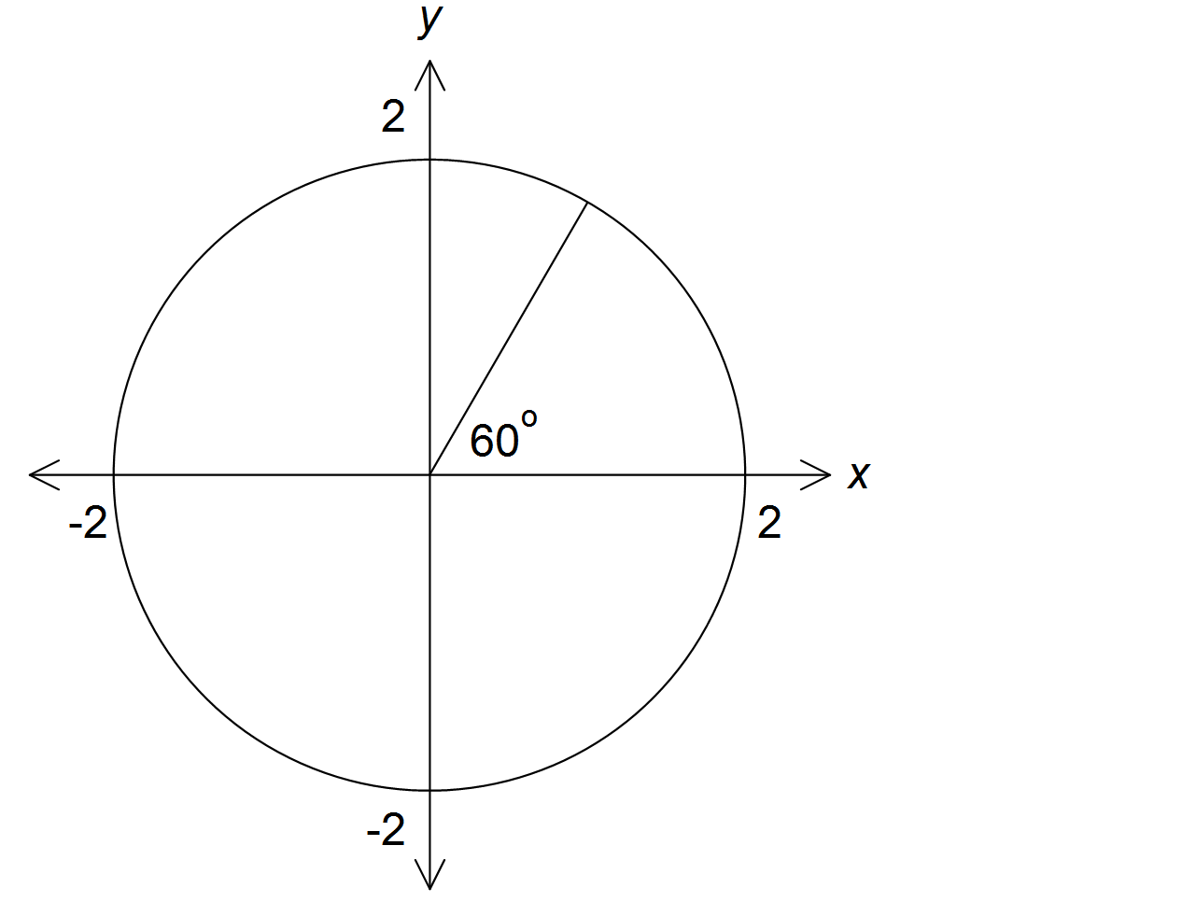

(i) Make a sketch of the remaining roots on the axes above.

[1]

|  |
| --- |
| **Solution** |
| z3  z1  z2  z0 |
| **Specific behaviours** |
| ✓ correctly places remaining 3 roots on axes |

(ii) Determine algebraically the value of *k* in Cartesian form.

[2]

|  |
| --- |
| **Solution** |
|  |
| **Specific behaviours** |
| ✓ determines *k* in polar form  ✓ determines *k* in Cartesian form |

(b) (i) Solve algebraically, using de Moivre’s theorem giving your answers in

Cartesian form.

[5]

|  |
| --- |
| **Solution** |
|  |
| **Specific behaviours** |
| ✓ Expresses in polar form  ✓ Expresses in polar form  ✓✓ three roots in polar form (only ✓ for 2 roots in polar form and 0 for 1 root)  ✓ each root in Cartesian form |

(ii) Solve algebraically.

[2]

|  |
| --- |
| **Solution** |
|  |
| **Specific behaviours** |
| ✓ recognises solutions are translation on , real component by -1  ✓ correct four solutions in Cartesian form |

**Additional working space**

Question number(s):

**Additional working space**

Question number(s):